**1.0 Introduction**

**1.1 Main Concept of the Capstone Project**

Sugar Industry in the Philippines plays a big role in supplying the world with an important commodity which is used in almost any part of our diet. Sugar Regulatory Administration is the one responsible for regulating the flow of the sugar industry here in the Philippines. As an organization it has experience problems. SRA is having difficulty in providing appropriate programs and recommendations to help increase the sugar production to meet the demands of the industry. This problem leads to under-productivity of the farmers in which, in the end, would affect the supply. It can also cause unnecessary imports if they do not know if the supply was too much or too less. The goal of the capstone is to develop a decision support system for SRA to help them to further assist their farmers in improving their overall productivity for increased global competitiveness of the country’s sugar industry as well as giving the organization an opportunity in planning the allocation of sugar.

**1.2 Background of the Study**

The sugar industry is important because it is responsible for supplying the world with sugar, which is used in most foods, and is important part of the human diet. Sugar is also found in many staple foods. The world produces 170 million metric tons of sugar every annually. Brazil is the top country in producing and exporting of sugar in 2013-2014. The United States produced 7.67 million metric tons of sugar in 2013-2014.

There are two crops that can produce two sugar, and they are sugarcane and sugar beet. In 2013, 2.7 billion metric tons of sugarcane were produced. Out of the global sugarcane produced, 739 million metric tons were from Brazil.

Other leading countries in the production of sugarcane are India, China, Thailand, and Pakistan. 250 million metric tons of sugar beets were produced worldwide in 2013. Russia and France led in the production of sugar beets. Brazil is also on the top in exporting sugar in 2013-2014, exporting greater than 26 million metric tons. China, Indonesia, and the United States are the top sugar importers. (“Sugar Industry - Statistics & Facts”, n.d.)

For the crop year of 2014-2015, the Philippines produced a total of 2,323,817 metric tons of raw sugar that came from 416,893 hectares of sugarcane. The yield per hectare was 111.48 Lkg/Ha. In the same crop year, 1,076,382 metric tons of sugar were produced.

**1.3 Background of the Domain**

**1.3.1 Background of the Organization**

The Sugar Regulatory Administration (SRA) is a Philippine government agency that was formed March 28, 1986. The agency’s objectives are: to institute an orderly system in sugar production for domestic consumption, exportation and reserves; to establish and maintain a balanced relation between production and demand of sugar and marketing conditions to ensure balanced prices that are reasonably profitable to producers and fair to consumers; to advocate the effective merchandising of sugar and sugar products in the in the domestic and foreign markets.

**1.3.1.1 Vision**

An empowered government organization that ensures long-term viability, environmental sustainability and global competitiveness of Philippine sugarcane industries through greater and significant participation of the stakeholders.

**1.3.1.2 Mission**

To provide stakeholders of the Philippine sugarcane industries with pro-active and effective policies, regulatory, R&D and extension services.

**1.3.2 Products and Services**

**1.3.2.1 Regulatory Services**

The agency enforces sugar policies and guidelines; issuances of licenses and registrations to sugar mills, sugar refineries, traders, and bioethanol producers; performs quality assurance and product analysis of raw and refined sugar, imported sugar and sugar premises. The SRA does monitoring of sugar production, withdrawals, imports and usage of CBW, stock balances, prices, and imports/exports.

**1.3.2.2 Production Support Services**

The SRA provides breeding and distribution of good varieties of sugarcane, analyzes soil samples for recommendations of fertilizer, creates studies for production technology, crop management, quality assurance and environmental.

**1.3.2.3 Extension Support Services**

The agency implements the block farm program for sugarcane farmers, transfers developed technologies on sugar production and sugarcane farming, gathers farm inventory, crop estimates; implements outreach programs for trainings of sugarcane farmers on farm practices and technologies; coordinates with MDDCs in implementing programs and projects.

**1.3.2.4 Policy and Information Support Services**

The SRA formulates, reviews, and propagates the policies on the allocation of produced sugar, products from sugar, sugarcane juice and syrups. The agency also develops information systems on sugar production and other related processes. A sugarcane industry roadmap is also created for the agency.

**1.3.2.5 Institutional Strengthening Program**

Through this program, the SRA Service Guide and the website contents are updated regularly, implemented programs, projects, and activities are monitored and evaluated. This also includes codification of SRA regulations and penalties.

**1.3.3 Organizational Units and Processes Involved**

**1.3.3.1 Transactional Processes**

The process starts with the planning for the crop estimate for an entire crop year. For the the whole crop year, there will be four main estimates which will be done quarterly. These are the pre-preliminary, preliminary, pre-final and final estimates. The pre-preliminary estimate is done before the start of the start of the planting season. This estimate is done by the mill district officer using the final production data from the previous crop year. A quarterly crop validation survey is done to gather the farm data from the individual farms of a district. A monthly crop monitoring is done by the agriculturist. This monitoring is done for checking the crop characteristics. A photo of the sugarcane crop is also taken. Afterwards the agriculturist or mill district officer will process all the data gathered and create the crop monitoring report. Next will be the the field observation which is done by the agriculturist as well. Here, the agriculturist go around each farm to do a visual observation of the area. The crop assessment report will then be created using the data from the observation as well as from the weekly factory statement coming from the mill. All of the reports will be sent to the SRA office where the technical staff will consolidate all of these reports. The data from these reports will be used to adjust the crop estimate. Finally, the weekly production statistics report will be created. These report will be used for the board meeting for the allocation of sugar and planning of programs, recommendations and advice for farmers.

**1.3.3.2 Managerial Processes**

The crop estimate for the current year is being planned based from the final production data from the previous crop year in order to know the target production.

The farming programs, advice and recommendation based on the productivity level of each district. That is based from the weekly production statistics report.

The SRA board members are the ones that decide the allocation of sugar to the four categories namely, US Export, Domestic, Reserve and World Export. The decision for allocation is mainly based from the actual production which comes from the weekly production report from the regulation department and the crop estimate from the weekly production statistics report. Another factor included would be the withdrawals. These are the sugar that has been procured by the traders from the mills. The withdrawals pertain to the basic demand of sugar since this shows the quantity of L/kg sugar bags that are being purchased. The quotas affect the allocation of sugar. The usual allocation is 96% for domestic. The sugar orders are based from how much supply the country has and the board members can change the policy depending on the need. Example is that they can allocate 100% of the total supply to domestic if the sugar supply is low.

|  |  |  |  |
| --- | --- | --- | --- |
|  | Decision being/should be made | Information Used | Problem |
| Planning | ● Planning of programs and projects    ● Planning of crop estimate for the crop year | ● Weekly Production Statistics Report    ● Final production data from the previous crop year | Underutilized data |
| Leading |  |  |  |
| Organizing | Assigning the MDO to their specific mill district for farmer assistance | ● Productivity level | None |
| Controlling | Sugar allocation among the four categories | ● Crop estimate  ● Actual Production  ● Withdrawals  ● Quotas |  |

**1.3.4 Organizational Structure**

At the top of the organizational chart is the Office of the Sugar Board who creates the policies related to the sugar industry and SRA. Under it is the Office of the Administrator which handles the SRA. It also recommends to the Sugar Board and also enforces or implements the policies set by the Sugar Board. The Planning and Policy Department is under the Office of the Administrates and it creates short, medium, and long term plans of the SRA.

Next is the Office of the Deputy Administrator where it assists in monitoring of the day-to-day activities of the SRA. The Regulation Department enforces policies, rules, and regulations that pertains to production, importation, exportation, withdrawals, and disposition of sugar and related products. The Research Development and Extension Department does research and development on farming of sugarcane, and sugar processing. The RD&E also recommends new technologies to farmers of sugarcane, sugar, and related products to increase their productivity.

**1.4 Problem Statement**

The main problem encountered by the company is the *difficulty in providing appropriate programs, projects, and farming recommendations.* This main problem is caused by having difficulty in interpreting and processing reports (such as weekly production statistics report, quarterly production reports, crop assessments, damage caused by calamities, crop monitoring, and crop validation survey) that identify causes of underproduction. Examples of the causes of underproduction are lack of fertilizer, poor irrigation, pests and diseases, and damages from calamities.

The main cause of the problem is then led by two causes as well which are the following:

**1.4.1 Tedious consolidation and retrieval of data**

The consolidation of data is tedious because whenever there are unforeseen factors such as typhoons and other calamities, the MDO would need to create a crop estimate. This is a requirement from the MDO because the crop estimate should be constantly updated, which makes it harder for the MDO since they have to regather data again for the crop estimate. These unforeseen factors greatly affect current and future estimates and are very important for the mill district officers when making the crop estimates. Because of that, data gathered needs to be always processed because of the constant changes to provide updated estimates.

**1.4.2 Underutilizing the factors for evaluating its impact to the crop estimate**

Different factors such as weather data, crop growth, and soil data are collected and not used for creating the crop estimate but are currently used for research purposes. Only data such as historical data from the previous year, actual production, harvest area, millable stalks and its weight from surveys, monitoring report and crop assessment are used while other factors are not processed with the used data in order to compute for a crop estimate. Most of the unused data are important factors in computing for a more reliable crop estimate. To use the said data in the crop estimate, it would mean that the model they are using currently for their estimate is not reliable enough since it does not include the said unused data. It would also require a non-stagnant changing model in order to consider the needed factors.

Aside from the previously stated causes, another reason why the factors for evaluating impact to the crop estimate is underutilized is because they have insufficient time to process reports. The reason behind this is because they lack people to gather and process reports. The MDO is the one responsible for both gathering and processing data of their district and they only have 5 days to gather and process their data. But they use most of their time in gathering through observations for the entire district having no time to process the gathered information. In addition to that, the MDO lacks the tools to process their data and understand how does each of the data affects the crop estimate. This would limit the range of recommendations that can be suggested by the MDO.

**1.5 Opportunities**

The system will enable the organization to use the data gathered to generate different simulations that will help the organization in deciding how to assist farmers in improving their productivity and determine the optimal agronomical practices. This opportunity is specific for the Extension division of the Research Development and Extension department since they are the ones who give suggestions to farmers. The system will be able to assist better on deciding the allocation of sugar that is being done by the board members. This could potentially help the sugar industry in meeting the quota of the four markets (e.g., US, Domestic, World, and Reserve).

**1.6 Significance of the Study**

**1.6.1 The Company**

This study will benefit Sugar Regulatory Administration by having a system that will aid the organization in calculating more accurate crop estimates that are essential for their decisions and policy making. This study will also give the organization the opportunity to improve their services better in terms of assisting and facilitating different programs for farmers to increase overall productivity.

**1.6.2 Clients**

The study will aid the farmers in terms of giving recommendations and suggestions to them based on the system’s assessment of their farms and sugarcane crop. The study is also aimed at enabling the Research Development and Extension department provide better suggestions and recommendations with the use of an information system. Having a system that will aid in crop assessment will be beneficial in giving more suggestive information to the farmers.

**1.6.3 The Future Project Proponents**

This study will aid the future proponents in their capstone project by providing them with an insight on what can be improved further in this study. This will also give the future proponents a brief idea on how the capstone project was developed. This study also serves as a guide for future proponents who would be tackling this kind of topic.

**1.7 Scope and Limitation of the Project**

The scope of the Decision Support System for SRA will cover the Research Development and Extension department. The system has five modules namely, Data Acquisition, Data Analysis, Allocation, Reporting and Farmer Recommendations and Assistance. Departments like Regulation and Planning will not be covered because it becomes out of scope. Only specific data from regulation department will be used, eg. Weekly Production Report.

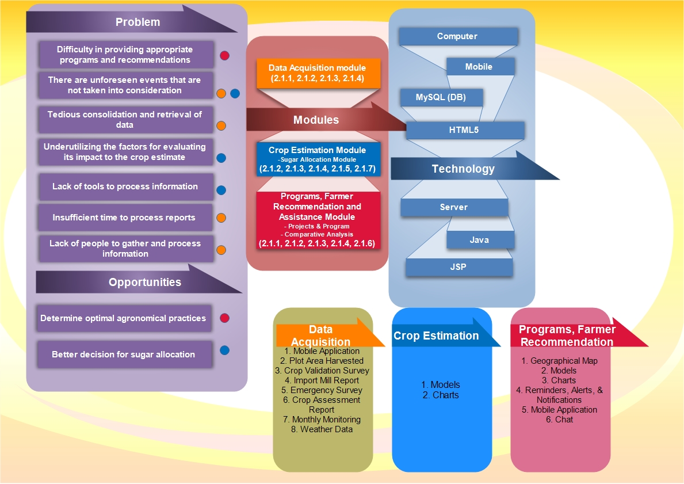 **1.8 Conceptual Framework/Solutions Framework**

**1.8.1 Solution Concept**

The proposed solution is composed of three major modules, namely, data acquisition module, crop estimation module (which includes sugar allocation), and farmer recommendation module. Users of the system include the MDO/agriculturist, farmers, SRA technical staff and the board members.

**1.8.2 Modules of the System**

**1.8.2.1 Data acquisition module**

This module will focus on acquiring the needed data for analysis for the next module. For the mobile application, the farmer will be able to plot the area of their farm using the geographical map so that they can determine how much is the actual area they have harvested and this data is synced to a common database and so the MDO can also see updates done by the farmers. This would later display how much percentage of the area has been harvested and is yet to be harvested. The farmers are also able to take a picture of their farm’s sample site with measurements to add to the survey as additional data or proof for the mill district officer. The farmers are also able to enter the amount of tons cane which they have given to the mills.

The mill district officer is able to import or encode the production data from the mills using a picture of a mill report. This data together with other factors like weather, soil and crop characteristics will be entered in order to be processed in the next module.

If the farmer is unable to plot his own farm to get the area harvested, then the mill district officer will be the one plotting it using the mobile application. The mill district officer will use the data from the map which is the area and the imported data needed from the mill to generate the crop assessment report. The mill district officer can add a narrative or remark to be used in the crop assessment report.

Whenever there are unforeseen scenarios like a typhoon, fire, drought or pest infestation that hits the district, the mill district officer can conduct an “emergency” survey which plots the area that has been affected by the scenario and can determine the amount of crops that have been damaged or destroyed. The mill district officer can also add comments or remarks on the damage that happened to the farms. The mobile application is used for this emergency survey. The emergency survey also contains the photo of the damage in the area which can serve as a basis for the remarks that will inputted by the MDO. To have a better estimate for the damage report, the mobile application of the farmers will enable them to plot from the map the area that is damaged by the calamity.

**1.8.2.2 Crop Estimation Module**

For the pre-preliminary estimate, the data to be used for calculating the initial estimate will be historical data which is from previous crop years. For the following quarters of the crop season, the crop estimate will be adjusted on a weekly basis. The crop estimate and productivity will be based on the generated crop assessment reports, crop validation survey, monthly monitoring report, and other factors such as weather and agronomic factors (e.g. sugarcane variety, plant/ratoon status, rainfall, N and K nutrition, and crop cycle). Crop estimate will be determined by the use of simulation models that can help derive to a reliable forecast. The first part of the estimate would be determining the total area of all farms then the second part would be determining the productivity of those farms. The simulations can be visualized using charts.

Creating the module requires an expert for the suggestions, recommendations and improvements of models to be used that are critical to the proposed system. Constant communication with the expert is needed as this module is being developed. Models to be used in this system are regression models. Each of the models used in the system are continuously customized and tested until the models can come up with a reliable crop estimates. Three (3) years’ worth of data from the past is going to be used. The required data can be gathered from SRA. The weather data such as rainfall to be used in the system during the actual operations are going to be gathered from PAG-ASA’s forecast (Data Acquisition Module) via the MDO. Soil analysis data can be gathered from the farmer’s profile. The models used in the system will then continue to adapt based on the actual production being inputted and updating factors that affect the estimate.

This module includes the sub module sugar allocation, which involves the decision for sugar allocation to the four categories which are US Export, Domestic, Reserve and World Export. They use factors such as crop estimate which is computed from the models, and the actual production. These information are displayed which will help the board members in making the decision for the sugar allocation. The crop estimate would work as the forecasted supply and the quota will act as the demand.

**1.8.2.3 Programs, Farmer Recommendations and Assistance Module**

The farming recommendations are based from the simulation of the factors inputted to the model by determining the weight of the factors of each individual farm that affect its productivity. The user can update the factors of the model in order to create multiple simulations that can determine its effect to farm’s potential yield and productivity. Comparative analysis can be done between the farms in order to determine optimal farming practices of each farm. This module can suggest recommendations based from the simulations and the comparative analysis. These are done by the technical staff in the SRA office.

The simulations can then be viewed by the board members and these can help determine problems that is causing that farm to be underproductive and then the board members can decide what recommendations should be approved and can be recommended to the farms. The board members can use a map that displays the details of each farm of the mill district. The details includes the farm's productivity, picture of the sample crop, farmer profile and farming practices used in each farm. These recommendations go to the MDO and then once approved, the mill district officer can send the farming recommendations to the farmers like irrigation, and drainage and cultivation. These can be viewed by the farmers from their mobile application and can be filtered based on classification. Ex. fertilization, irrigation, replanting, etc.

**Programs sub Module**

A submodule would consist of the programs and projects, the board members would be able to see in the map the area in which current programs and projects have been implemented in a specific area in the district. Example of programs and projects is the creating of a new infrastructure in between farm A and farm B or having a training program for a new farming method. Then with this and the details of each farm, the board members are able to plan and create new programs that is necessary for the area. Details of the programs would be displayed. The system would be able to record the difference and improvement in productivity from before, during and after the program has been implemented. Based on this, the board members could decide whether to keep the program or update it.

**Assistance sub module**

The mill district officer can also send weather updates to the farmers and notifying if there would be a possible typhoon and that the MDO can also recommend the farmers to harvest the remaining crop. The farmer will be notified from the mobile application and can decide whether to harvest the crop if needed. Additional updates can also be given to the farmers as needed. These are the assistance that are not required to go through the board members. The farmers can inquire to the mill district officer through the mobile application if they have questions or concerns regarding their farms. Through the chat feature, the farmer can ask for assistance from the mill district officer if the farmer does not clearly understand the farming practice that was recommended to them. The farmers can set reminders such as when to apply fertilizer, or when to update their information for surveys for data gathering.

**1.9 Objectives of the Study**

**1.9.1 General Objective**

The general objective of the study is to develop a decision support system for Sugar Regulatory Administration.

**1.9.2 Specific Objectives**

The group aims to:

● Gather information about the organization’s background, business requirements and processes through interviews.

● Understand the concept of decision support system and how it would help improve the organization’s managerial decisions.

● Conceptualize a solution that will cater to the organization’s needs.

● Design a graphical user interface that will fit the needs of the users

● Create test scenarios to check if the processes and modules are aligned with the proposed solution